Assignment 2: Your organization has 5 departments namely HR, Finance, Training, Operations,

and Security. Create files file1 and file2 in the HR directory and then move file2 to the

Training department while you copy file1 and file2 to the remaining departments.

To accomplish this task, I use commands in a Linux. Here's a step-by-step guide to achieve this:

**Step 1:** I created the Department directory and the directories for each department:

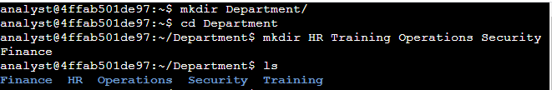

**Step 2: I created files file1.txt and file2.txt in the HR directory:**



**Step 3: I copied files file1.txt and file2.txt in the HR department directory to other department that is Finance, Operations and Security**

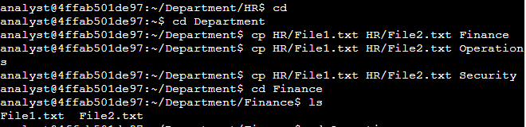

**Step 4: I moved file2.txt from HR department directory to the Training department directory:**

